Infosys Springboard Virtual Internship 6.0 Completion Report
Batch Number: 6
Start date: 27/11/2025
Name: Ijare Onkar Umakant
Internship Duration: 8 Weeks

1. Project Title
AI-Based Intelligent System for Skin Disease Detection and Healthcare Recommendation.

2. Project Objective
Describe the main goal of the internship project. The primary objective of this project was to design and develop an AI-powered web application capable of identifying common skin diseases from uploaded images.
The project aims to assist users in early detection, raise health awareness, and reduce dependency on immediate dermatologist consultations, especially in remote or underserved areas.

3. Project description in detail
The Skin Disease Detection Project is a web-based application integrated with Artificial Intelligence and Machine Learning techniques to analyse skin images and predict possible skin conditions.
Approach
- Collected and pre-processed skin disease image datasets.
- Built a Convolutional Neural Network (CNN) model for image classification.
- Integrated the trained AI model with a Django-based backend.
- Designed a simple and user-friendly frontend for image upload and result display.
Technologies Used
- Frontend: React-Native
- Backend: Python, Django
- Database: SQLite
- AI/ML: TensorFlow, CNN
- Tools: VS Code, Git.
Real-World Impact
- Enables early identification of skin diseases.
- Assists users in deciding when to seek professional medical advice.
- Can be extended for use in clinics, telemedicine platforms, and healthcare camps.

4. Timeline Overview
Week | Activities Planned | Activities Completed
Week 1 | Problem understanding & research | Skin disease study completed
Week 2 | Dataset collection | Skin disease study completed
Week 3 | Data preprocessing | Image preprocessing implemented
Week 4 | Model development | CNN Model trained
Week 5 | Backend development | Django Backend setup
Week 6 | Frontend integration
  UI & image upload feature
Week 7 | Testing & optimization | Accuracy improved
Week 8 | Final optimization & documentation | Project completed

5a. Key Milestones
Milestone | Description | Date Achieved
Project Kickoff | Problem Definition and planning | Week 1
Prototype/First Draft | Initial working model | Week 4
Mid-Term Review | Model and UI review | Week 6
Final Submission | Completed Project | Week 7
Presentation | Project Demonstration | Week 8

5b. Project execution details
The project was executed in a structured manner starting from requirement analysis and dataset research.
A CNN-based AI model was trained using labeled skin disease images. The trained model was integrated with Django using REST-based communication.
Frontend and backend components were tested together to ensure smooth image uploads, predictions, and result display.

6. Snapshots / Screenshots

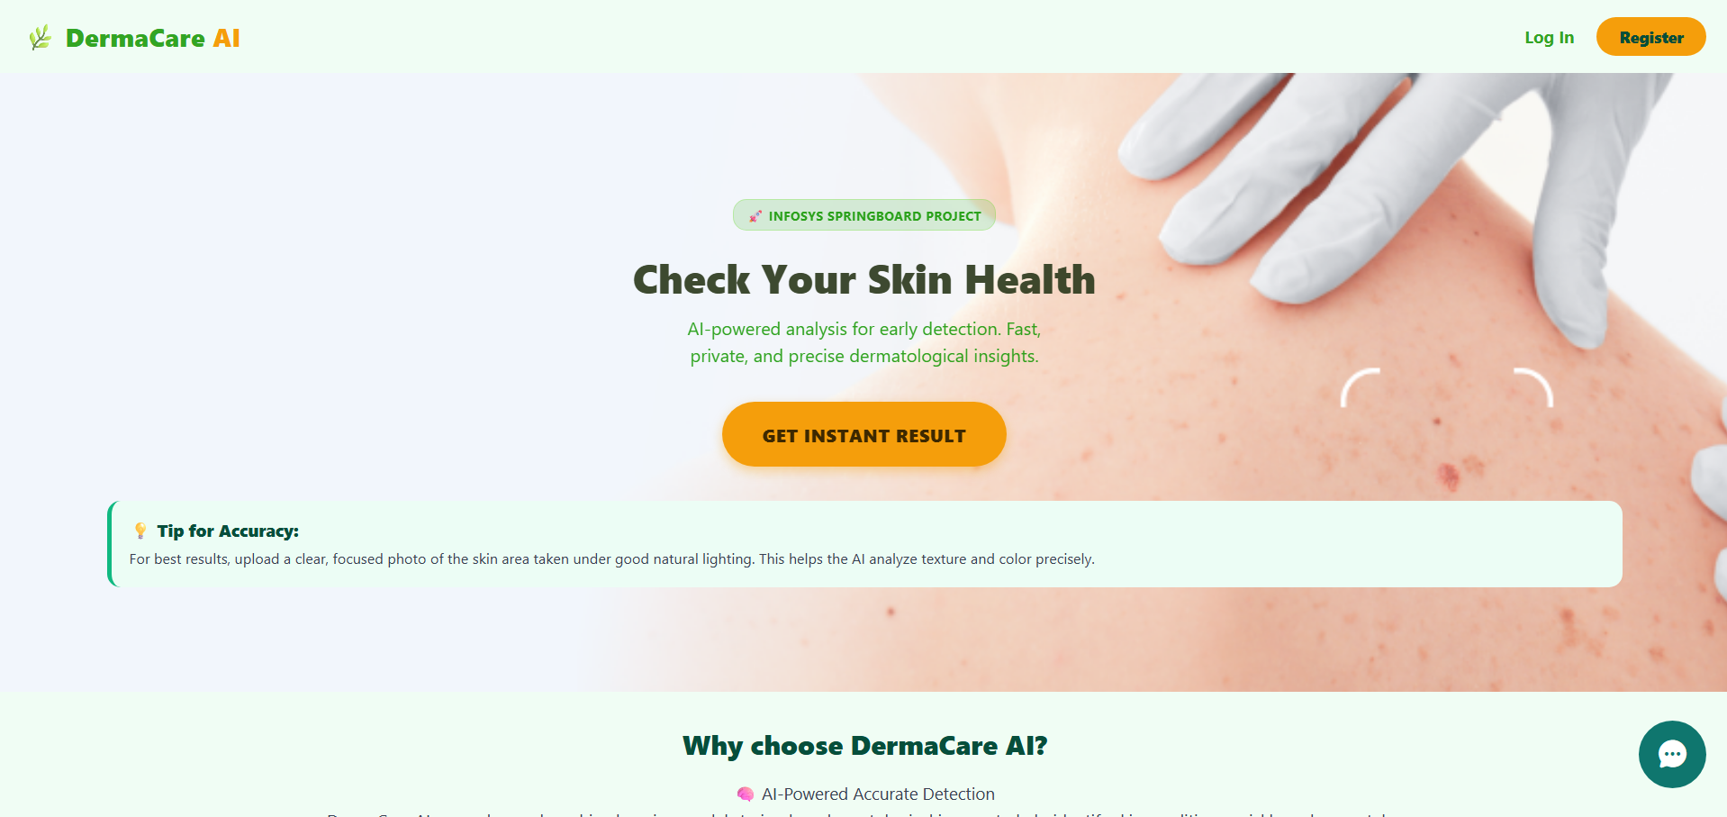
Fig.1: Home Page UI

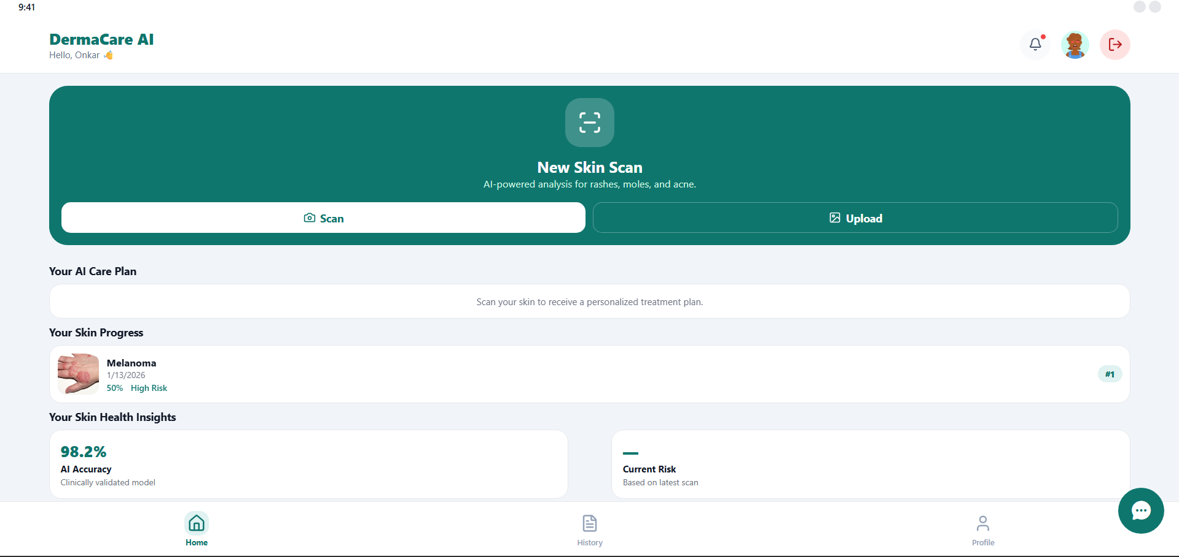
Fig. 2.1: Scan Page UI
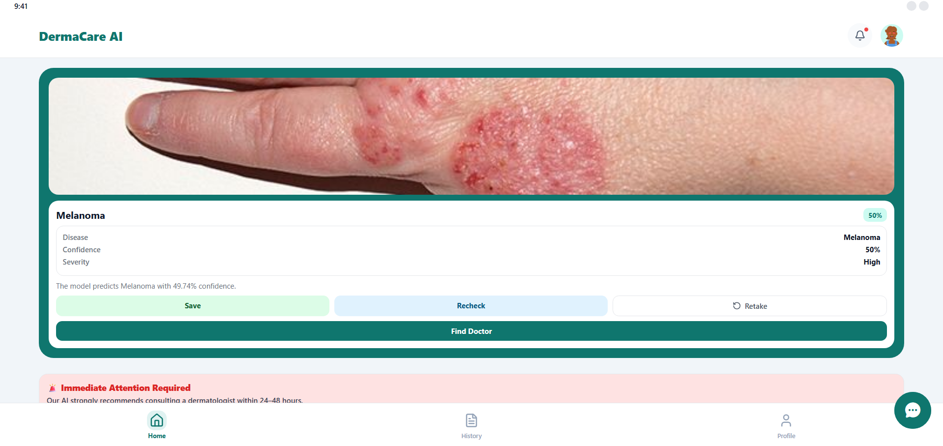
Fig. 2.2.1: Scan Result

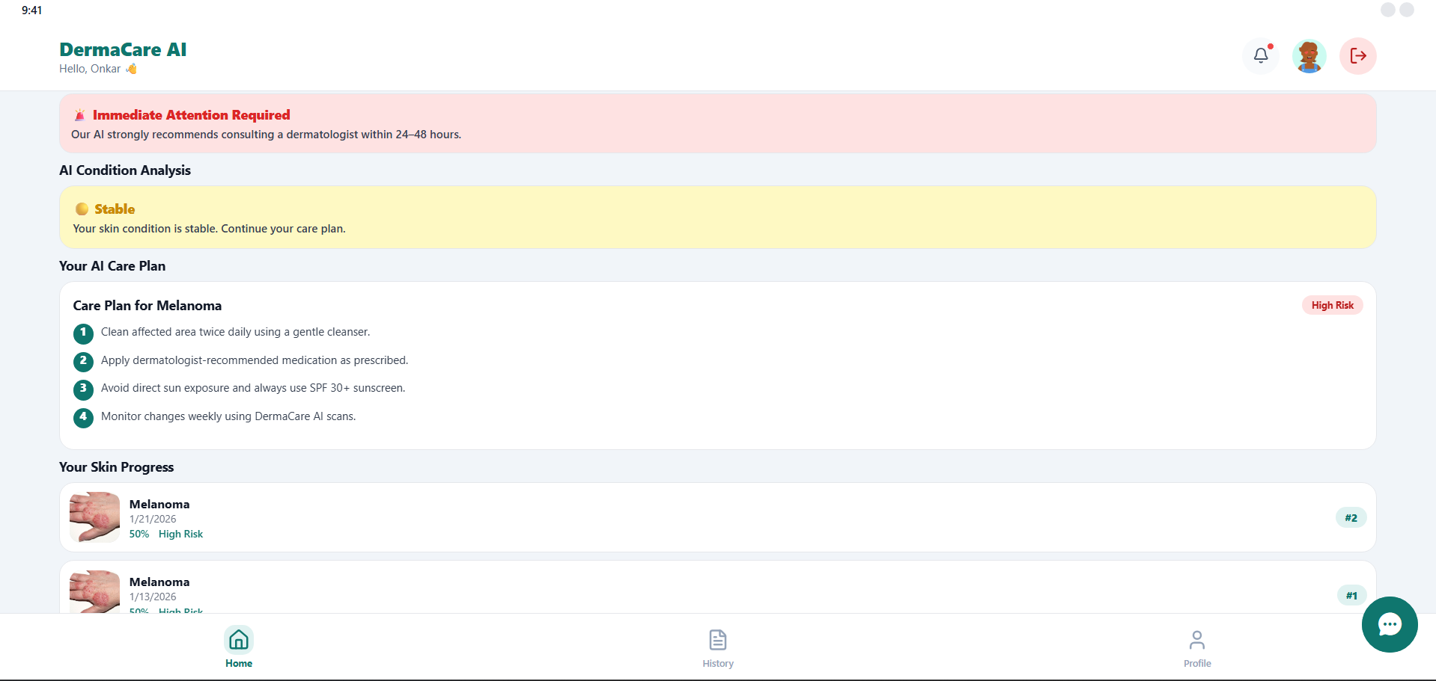
Fig. 2.2.2: Scan Result
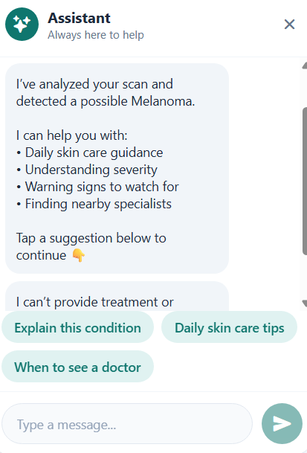
Fig. 2.3: Realtime ChatBot
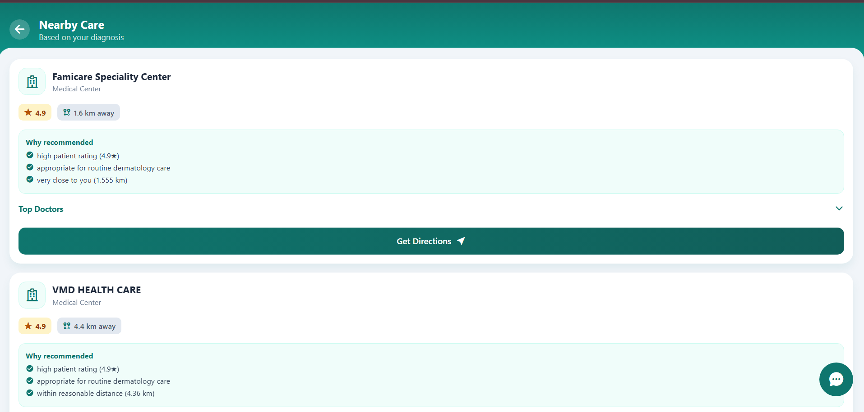
Fig. 2.4: Recommended Nearby Hospitals

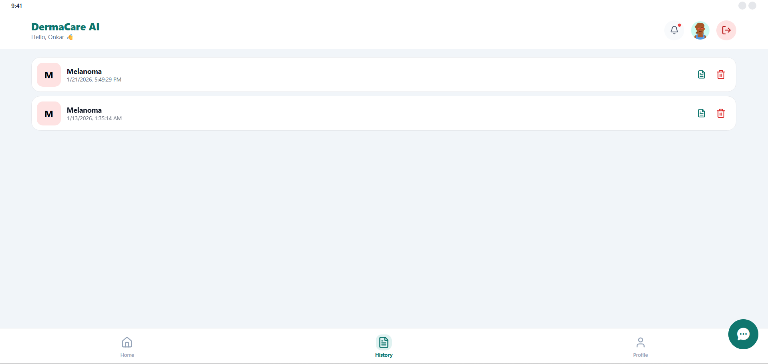
Fig. 3.1: Scan History
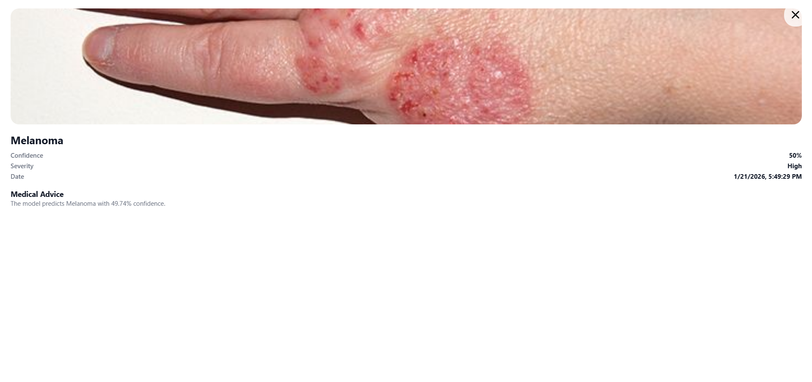
Fig. 3.2: Scan History Detailed

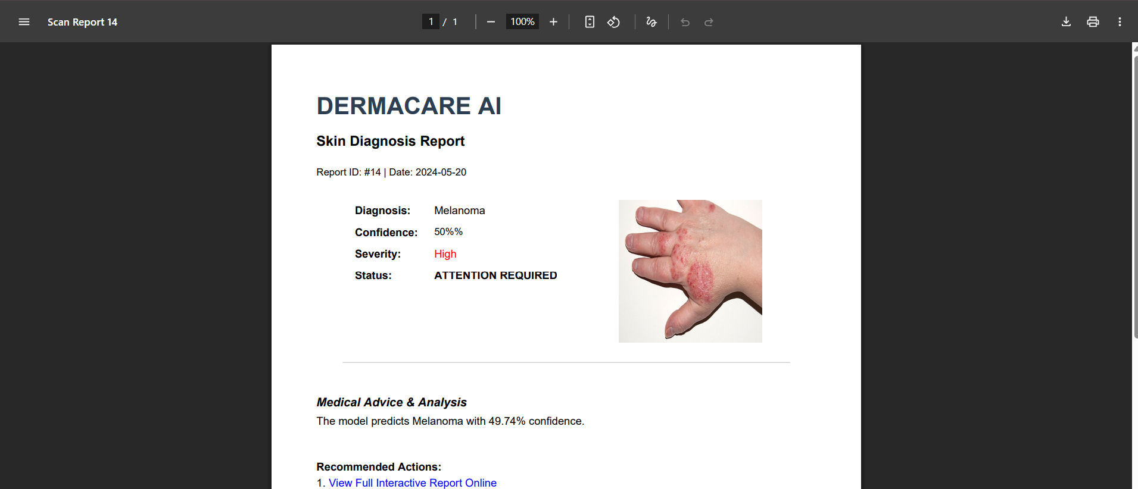
Fig. 3.3: Scan PDF

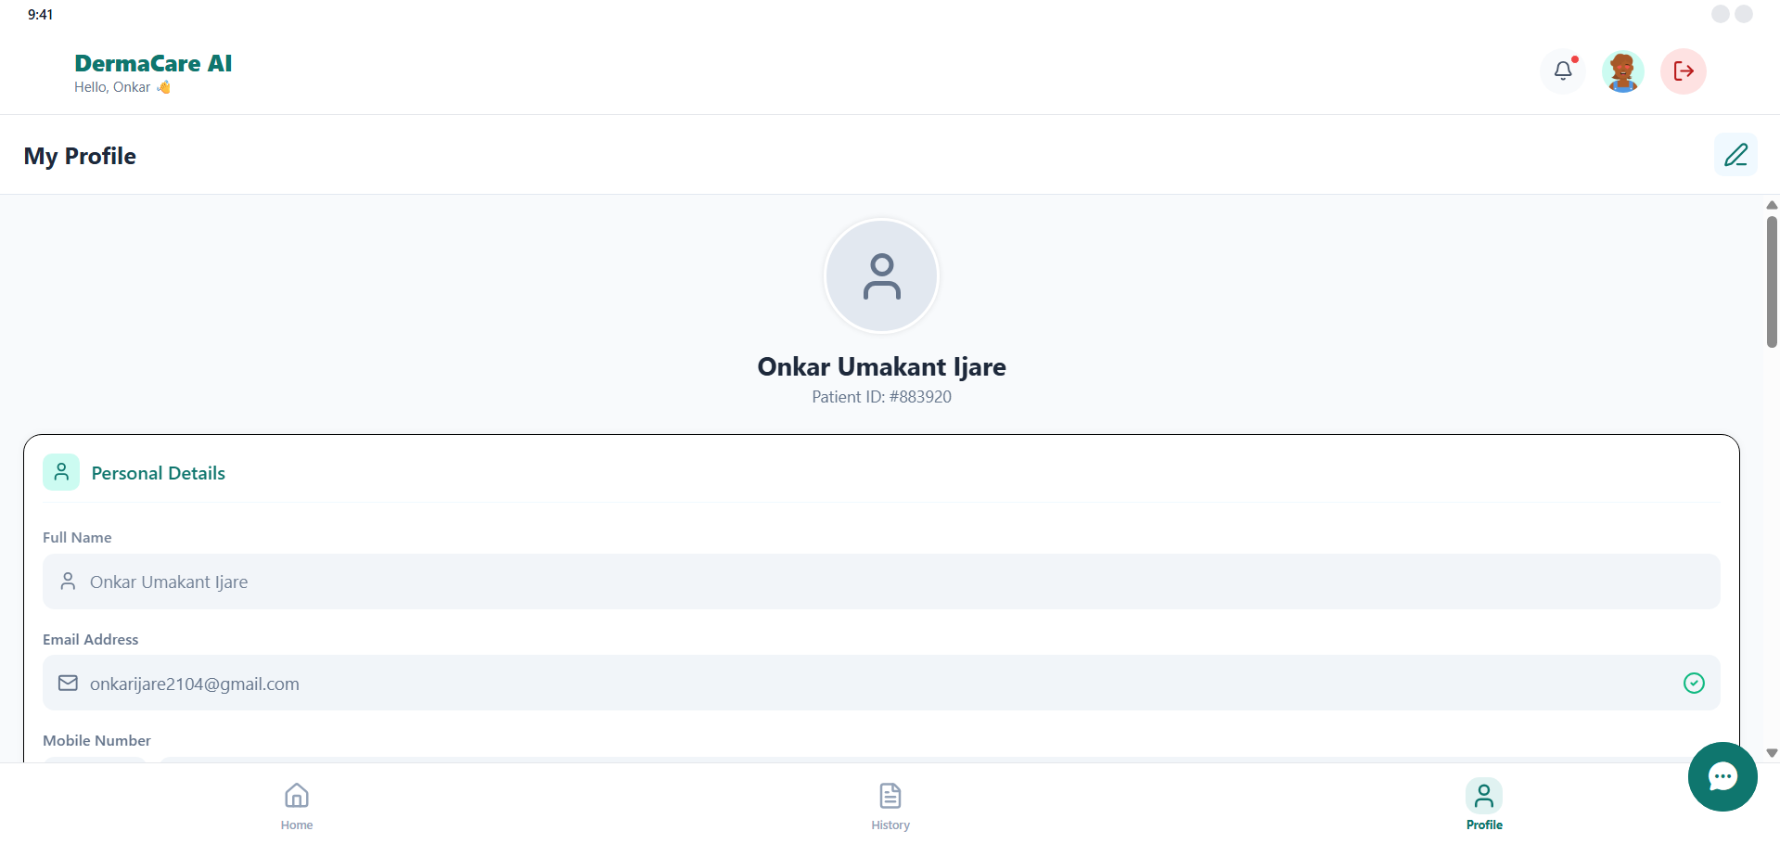
Fig. 4.1: Profile Section
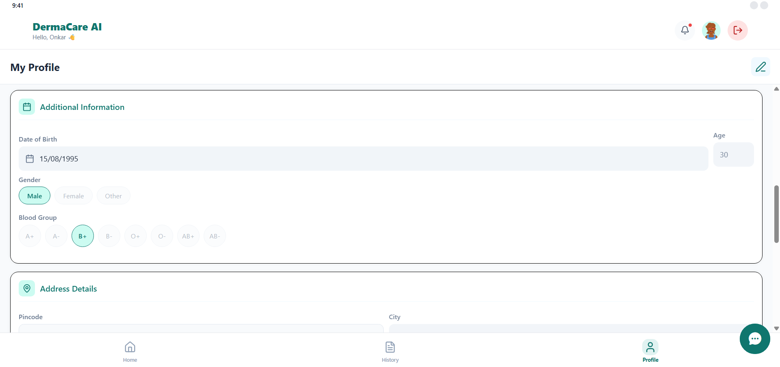
Fig. 4.2: Profile Section

7. Challenges Faced
Challenge 1: Image Quality Issues
- Solution: Implemented image resizing and normalization techniques.
Challenge 2: Model Accuracy
- Solution: Increased dataset size and optimized CNN layers.
Challenge 3: AI–Web Integration
- Solution: Used Django views and APIs for seamless integration.

8. Learnings & Skills Acquired
- Machine learning & CNN Fundamentals.
- Django Backend development
- Problem solving and debugging
- Team collaboration and documentations skills

9. Testimonials from team
This internship provided hands-on experience in building real-world AI applications. Working as a team helped us improve both technical and communication skills.

10. Conclusion
The internship was a valuable learning experience that strengthened our understanding of AI, web development, and healthcare-based solutions.
The project successfully demonstrates how AI can be used for social impact and aligns well with future career goals in software and AI development.

11. Acknowledgements
I sincerely thank Infosys Springboard, our mentors, and the internship coordinators for providing guidance, resources, and continuous support throughout the internship journey.

